Birmingham Food Refusal Services 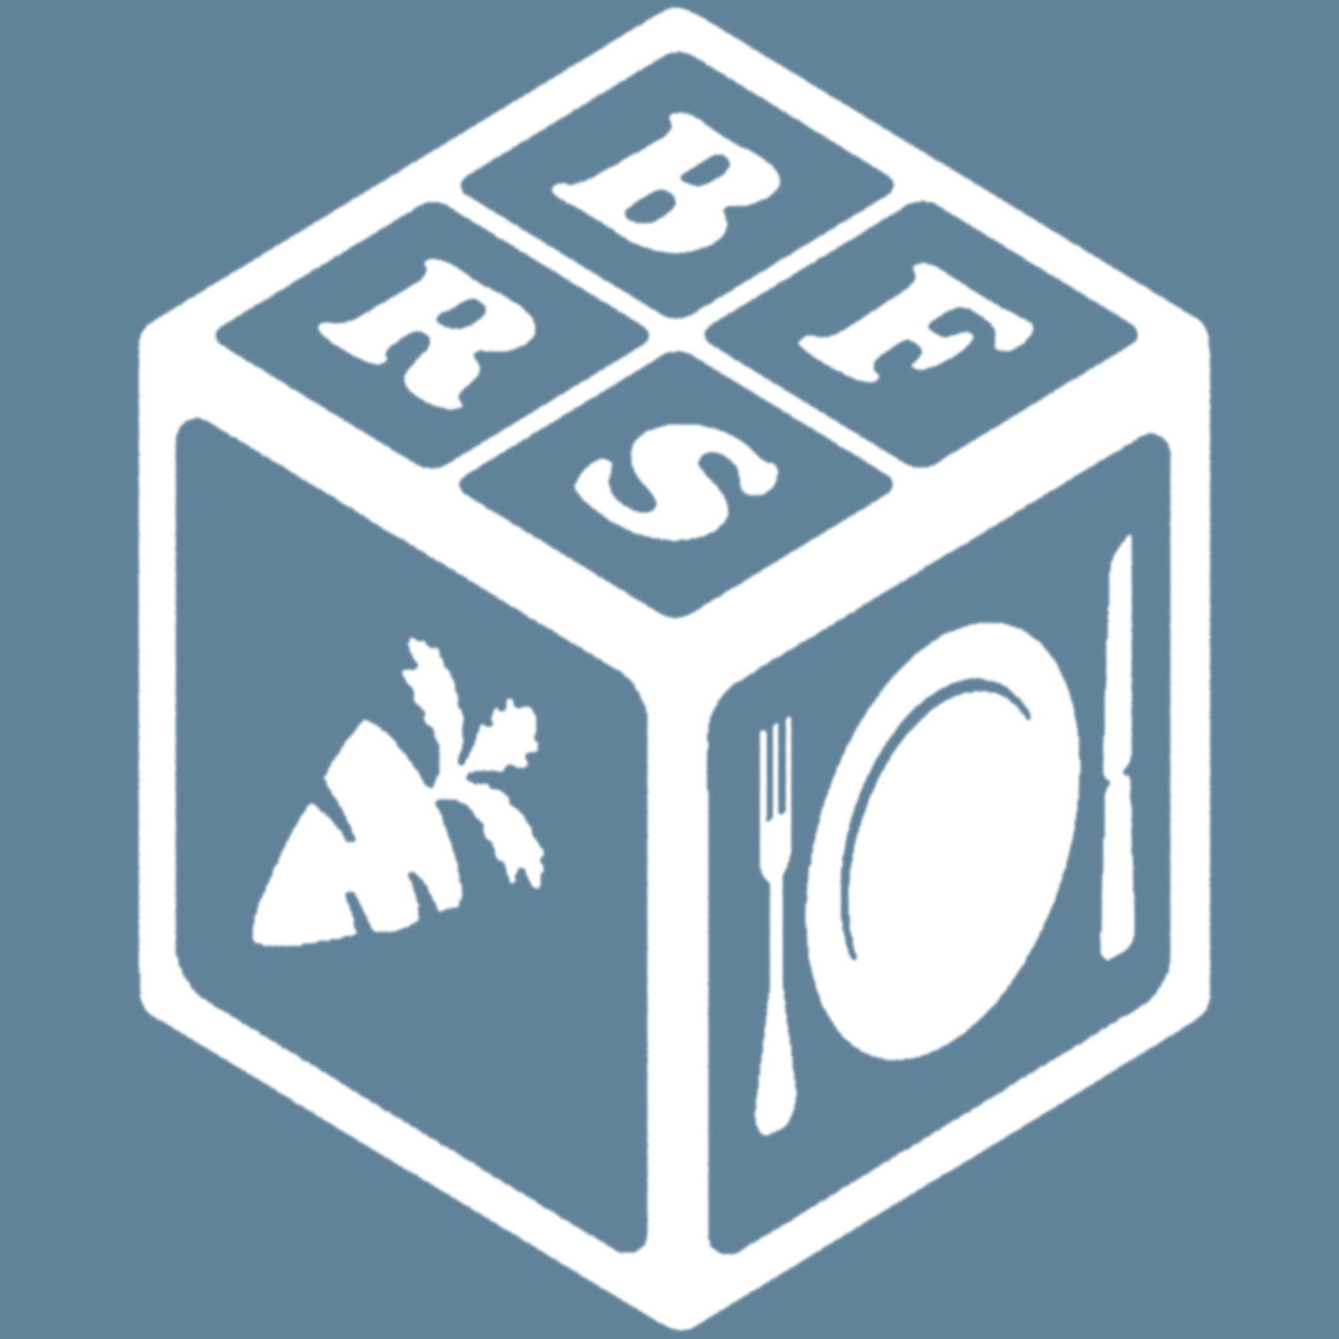

Registration Form and Payment Form
Why do children refuse foods? Understanding avoidant and restrictive eating – a course for professionals
Monday 26th July 2021
Online training 9.30am – 12.30pm
Name of applicant:
Profession and role:
Address:
Email: Telephone number
Signed: Date:

Please return the registration and payment form by email to sarah.mason@foodrefusal.co.uk

The six places on this workshop will be allocated on a first come first served basis. I will let you know that a place is available for you, at which point you can make the payment to confirm your place.

Payment Due: £160

How to pay:
Payment is by bank transfer:
Please make a payment to:
Lloyds Bank
Account Name: Gillian Greville-Harris and Sarah Mason
Account number: 46443468
Sort code: 77-85-21

Return the payment form electronically to sarah.mason@foodrefusal.co.uk

Terms and conditions

Cancellation of online courses

Cancellation by you
You have the right to cancel any contract for the provision of a place on our workshops at any time within seven working days of entering a contract, beginning on the day after you have received an email confirming your booking. You will receive a full refund of the price paid for the workshop, if you cancel within seven days, with the following exceptions:
- there is no right to cancellation where the workshop begins within fourteen days beginning on the day after we sent the confirmation of your booking.
Once the seven day period following confirmation of your contract expires, cancellation charges will apply. This is because our bookings involve costs such as preparing materials. It is difficult to fill spaces made vacant by late cancellations.
Cancellation charges depend on when we receive your written/emailed cancellation notice:
- If cancelled 21 days before the course start date, we will refund 50% of course fees. If the invoice is unpaid at the time of cancellation, you will pay 50% of the fee due.
- There will be no refund of course fees if cancellation is less than 21 days before the course start date.

To cancel a place on a course, or to transfer or substitute someone else, please write to us explaining your reason for requesting the cancellation and details of the workshop.
To cancel a contract please inform us by an email to: sarah.mason@foodrefusal.co.uk
If you are due a refund, this will be made in the manner that the fees were paid to us. However, we do not accept any liability for any other costs or losses incurred.

Non-attendance due to exceptional circumstances
Non-attendance at the course due to illness, personal or professional reasons does not give rise to the right to refunds or a transfer.

Data protection
Your personal information will be held and used in accordance with the Data Protection Act 1998. Your details will not be shared with any other agencies.

Variations to the Terms and Conditions
We reserve the right to vary these Terms and Conditions from time to time and the current version will be that published on the website.
Please read these terms and conditions carefully before booking your place on a Birmingham Food Refusal Services online training course.
Date: March 2nd 2021
I have read and understood the terms and conditions. Please tick [ ]
Signed: Date:

